|  |  |  |
| --- | --- | --- |
| HRM Use-case Description | November 29  2011 | |
|  | | Manage Probation Progress |

Table of Contents

1 Use Case Description 3

1.1 Brief Description 3

1.2 Actors and UC Associations 3

2 Pre-conditions 3

3 Post-conditions 3

4 Flow of Events 3

4.1 Basic flow – View information 3

4.1.1 The flow starts: 3

4.2 Alternative Flow 1 – Add new information 4

4.3 Alternative Flow 2 – Edit information 4

The flow starts: 4

4.4 Alternative Flow 3 – Delete information 5

The flow starts: 5

4.5 Alternative Flow 4 – Print data 5

The flow starts: 5

4.6 Alternative Flow 5 – Export file 5

4.7 Alternative Flow 6 – Import file 5

5 Exception Flow 6

5.1 Exception Flow 1 – Add, Edit information 6

5.2 Exception Flow 2– Disconnection database 6

6 Activities Diagram 7

7 Business Rules 8

8 Special Requirements 8

# Use Case Description

## Brief Description

This use case allows user to Manage Probation Progress.

The following flows are described in this document:

* View information
  + Search information
  + Sort information
  + Filter information
* Add new information
* Edit information
* Delete information
* Print data
* Export file
* Import file

## Actors and UC Associations

**Actors:**

* Human Resource Planning and Managing Department members

**Use Case Associations:**

# Pre-conditions

1. User must log into HRM system
2. User has access Manage Probation Progress tab.

# Post-conditions

The information is viewed or updated.

# Flow of Events

## Basic flow – View information

### 4.1.1 The flow starts:

1. User is in a personal information management page and chooses menu “Detail Information management”.
2. The system displays a page as described in GUI – Detail Information Management, with all personal information had been stored in HRM system before.

The flow ends.

4.1.2 Search information

1. User inputs object that needs to search in a text field

2. User chooses “Search” button

3. The system handles and displays the information that user needs

The flow ends.

4.1.3 Sort information

1. User chooses object in a list to sort

2. The system handles and displays the information that user needs

The flow ends.

4.1.4 Filter information

1. User chooses object in a list to filter

2. The system handle and displays the information that user needs.

The flow ends.

## Alternative Flow 1 – Add new information

The flow starts:

1. User chooses menu “Manage Probation Progress”.
2. The system displays a tab as described in GUI – Manage Probation Progress.
3. Click button “add”
4. User input data
5. User can choose “OK” button or “Cancel” button.

* If user choose “OK” button, data will be saved.
* If user choose “Cancel” button, data won’t be saved.

The flow ends.

## Alternative Flow 2 – Edit information

### The flow starts:

1. User chooses menu “Manage Probation Progress”.
2. The system displays a tab as described in GUI – Manage Probation Progress.
3. Choose information need edit
4. Click button “edit”
5. User can choose “OK” button or “Cancel” button.

* If user choose “OK” button, data will be saved.
* If user choose “Cancel” button, data won’t be saved.

The flow ends.

## Alternative Flow 3 – Delete information

### The flow starts:

1. User chooses menu “Manage Probation Progress”.
2. The system displays a tab as described in GUI – Manage Probation Progress.
3. Choose information need delete
4. Choose delete this information
5. User can choose “OK” button or “Cancel” button.

* If user choose “OK” button, data will be saved.
* If user choose “Cancel” button, data won’t be saved.

The flow ends.

## Alternative Flow 4 – Print data

### The flow starts:

1. User chooses menu “Manage Probation Progress”.
2. The system displays a tab as described in GUI – Manage Probation Progress.
3. Choose “print” button

The flow ends.

## Alternative Flow 5 – Export file

The flow starts:

1. User views the information, and chooses “Export” button
2. The system handles request and display all fields that user needs
3. User chooses “OK” button
4. The system handles and export file that consists all file that is chosen.

The flow ends.

## Alternative Flow 6 – Import file

The flow starts:

* 1. User view the external file (excel), and chooses “import” button
  2. Choose this file viewed in browse
  3. User chooses “OK” button
  4. The system import this file in interface and user can edit it.

The flow ends.

# Exception Flow

## Exception Flow 1 – Add, Edit information

1. At step 3 of Alternative flows, the user chooses “Cancel” button
2. The system displays a message “Do you really close it”
3. The actor acknowledges message
4. The system closes the message, doesn’t save data and back to personal management page

The flow ends

## Exception Flow 2– Disconnection database

1. At step 3 of Alternative flows, HRM system disconnects database
2. The system displays a message “HRM disconnect”
3. The actor acknowledges message
4. The system closes the message, back to log in page.

The flow ends

# Activities Diagram

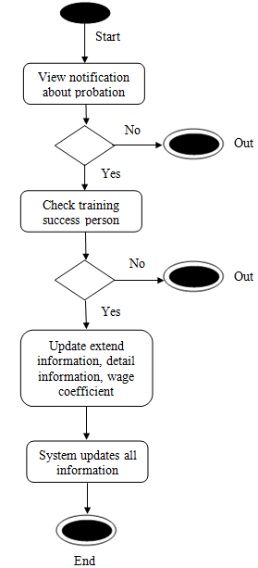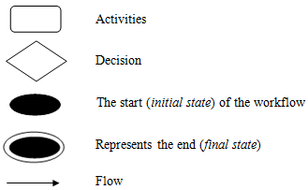

# Business Rules

# Special Requirements

Use case can satisfy security and performance.